1. Recently, the demand for data-related jobs such as Data Analyst, Business Analyst, Data Science, and Software Engineering has increased significantly due to the growing importance of data-driven decision-making in various industries. As a result, the offer salaries for these positions have generally exceeded the prevailing wages. The average paid wage per year for a Data Analyst is $70,030, while the average prevailing wage per year is $62,754. Similarly, the average paid wage per year for a Data Scientist is $108,021, while the average prevailing wage per year is $90,545.

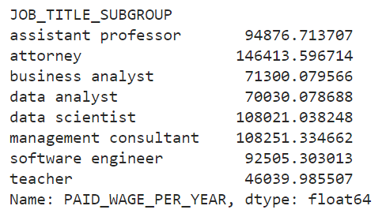

The reason behind this trend is the shortage of skilled and experienced candidates in the job market. Employers are willing to pay a premium for talented data professionals who can help them leverage data to drive business insights and strategy. Moreover, the constantly changing of data science and technology field requires continuous learning and development, which limits the available pool of qualified candidates.

On the other hand, non-data related jobs such as Assistant Professor, Teacher, Management Consultant, and Attorney have higher prevailing wages compared to their offer salaries. For instance, the average prevailing wage per year for an Attorney is $106,648, while the average paid wage per year is $146,413. Similarly, the average prevailing wage per year for an Assistant Professor is $58,831, while the average paid wage per year is $94,876.

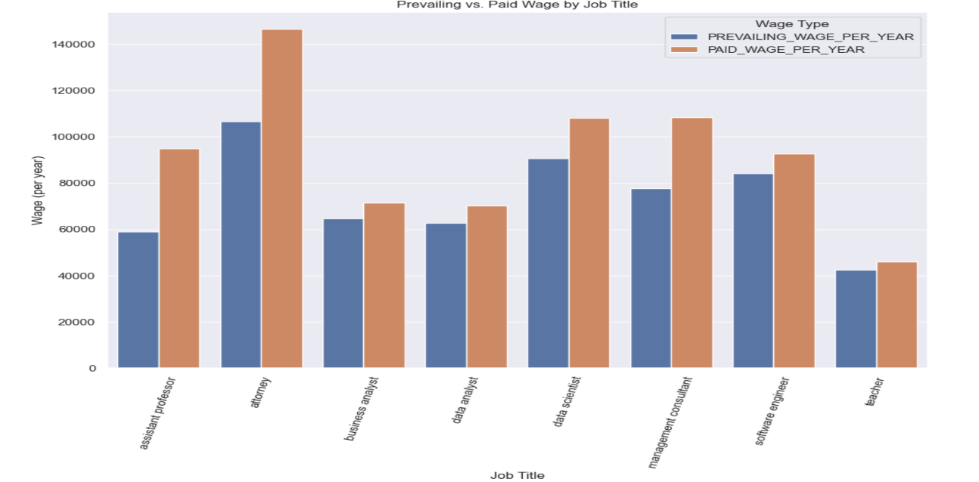

The reason for this could be the specific requirements for these positions such as advanced degrees, specialized skills, or licensing, which make it difficult for employers to find suitable candidates willing to accept lower pay. In addition, the academic and legal professions have been linked to better job security and benefits, which may impact the pay system.

In conclusion, the comparison between prevailing wages and paid wages for different job roles highlights the interaction between demand in the job market and specific skill requirements. While the trend of higher offer salaries for data-related jobs and higher prevailing wages for non-data related jobs can be observed from the data, the specific factors contribute to this trend may differ based on the specific job title, industry, location, and other factors.

1. The comparison between prevailing wage and paid wage per year according to employer name highlights the significant differences in salaries across different companies. The data reveals that some employers pay their workers significantly more than the prevailing wage, while others pay less.

For example, the employer (Household of Sandra Sirugo & Jorge D. Jaury) pays a paid wage per year of $41,288, which is only $83.2 more than the prevailing wage per year of $41,204.8. On the other hand, 1 to 1 Marketing LLC pays a paid wage per year of $93,333.33, which is $28,423.33 higher than the prevailing wage per year of $64,910.

Overall, the differences between prevailing wages and paid wages per year suggest that certain employers may prioritize specific skills, experience, or qualifications. It could also indicate differences in abilities or skills between employers and employees. However, it is important to note that the specific factors influencing the difference in salaries may differ based on the employer, industry, location, and other factors.

1. The comparison between prevailing wage and paid wage per year according to employer name reveals that some employers pay their workers less than the prevailing wage, while others pay close to the prevailing wage. For example, Access One ATM, Inc. pays a paid wage per year of $20,800, which is $6,240 lower than the prevailing wage per year of $27,040. Similarly, Aegis Foundry, LLC pays a paid wage per year of $70,000, which is $6,140 lower than the prevailing wage per year of $76,140.

Moreover, some employers pay their workers slightly less than the prevailing wage, as in the case of Ace Tech, Inc. which pays a paid wage per year of $52,765.60, which is only $1,966 less than the prevailing wage per year of $54,731.60. However, it is important to note that this difference in salaries could still impact employees' overall financial stability.

On the other hand, there are employers who pay significantly less than the prevailing wage, as in the case of Advanced Information Management Technology Partner, which pays a paid wage per year of $82,500, which is $18,580 lower than the prevailing wage per year of $101,080. The salaries gap could suggest that these employers have different cost structures or specific skills, experience, or qualifications compared to the market.

Overall, the data suggests that there is a significant difference in how much employers pay their workers relative to the prevailing wage, which could have an impact on the employees' overall financial stability and job satisfaction.

1. There will be a significant effect if taking standard of living into account. Location not only differentiates between high and low salary, but it also determines how people life will be. For example, the total amount a person actually earns in a month after deducting all living expenses will not be significantly better if he or she live at a place with high cost of living compared to one having same salary but living at a place with lower cost of living.